Please make sure to save/push all your code in the branch feature-java created in the previous week assignment as part of your github repo rg-assignments

Please share your output screenshots in the assignment document along with the github link for each question. Provide an explanation wherever possible as part of your response :-)

- Given:
public class TaxUtil {
double rate = 0.15;

public double calculateTax(double amount) {
return amount * rate;
}
}
Would you consider the method calculateTax() a 'pure function'? Why or why not?
If you claim the method is NOT a pure function, please suggest a way to make it pure.

Ans 1) No, calculateTax() is not a pure function.
Reason: It uses an instance variable rate, which means its output can change based on the object's state. A pure function must:
- Always return the same output for the same input
- Have no side effects and not depend on external state

Pure Function:
public class TaxUtil {
public double calculateTax(double amount, double rate) {
return amount * rate;
}
}

2)
What will be the output for following code?
class Super
{
static void show()
{
System.out.println("super class show method");
}
static class StaticMethods
{
void show()
{
System.out.println("sub class show method");
}
}
public static void main(String[]args)
{
Super.show();
new Super.StaticMethods().show();
}
}
Ans 2)
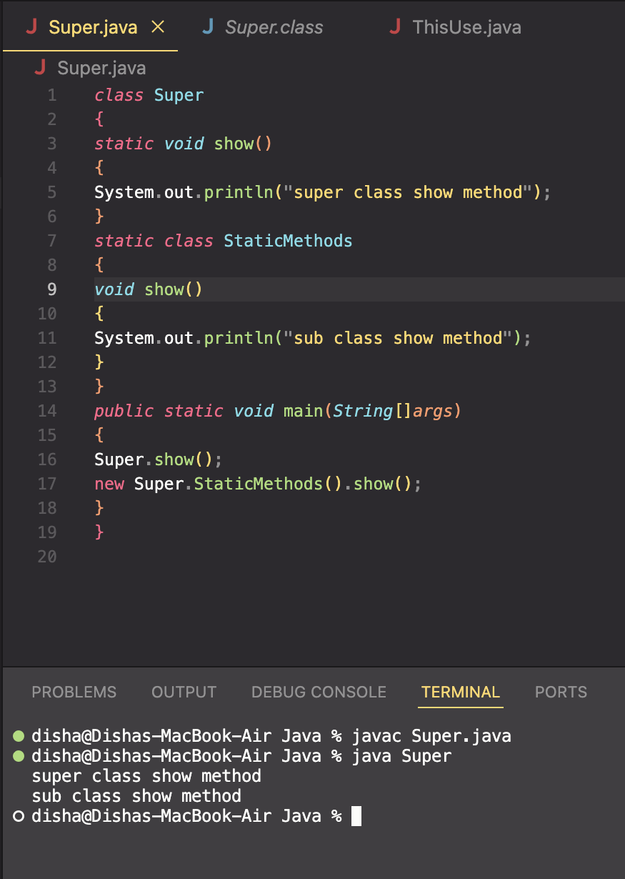

3)
What will be the output for the following code?
class Super
{
int num=20;
public void display()
{
System.out.println("super class method");
}
}
public class ThisUse extends Super
{
int num;
public ThisUse(int num)
{
this.num=num;
}
public void display()
{
System.out.println("display method");
}
public void Show()
{
this.display();
display();
System.out.println(this.num);
System.out.println(num);
}
public static void main(String[]args)
{
ThisUse o=new ThisUse(10);
o.show();
}
}

Ans 3)

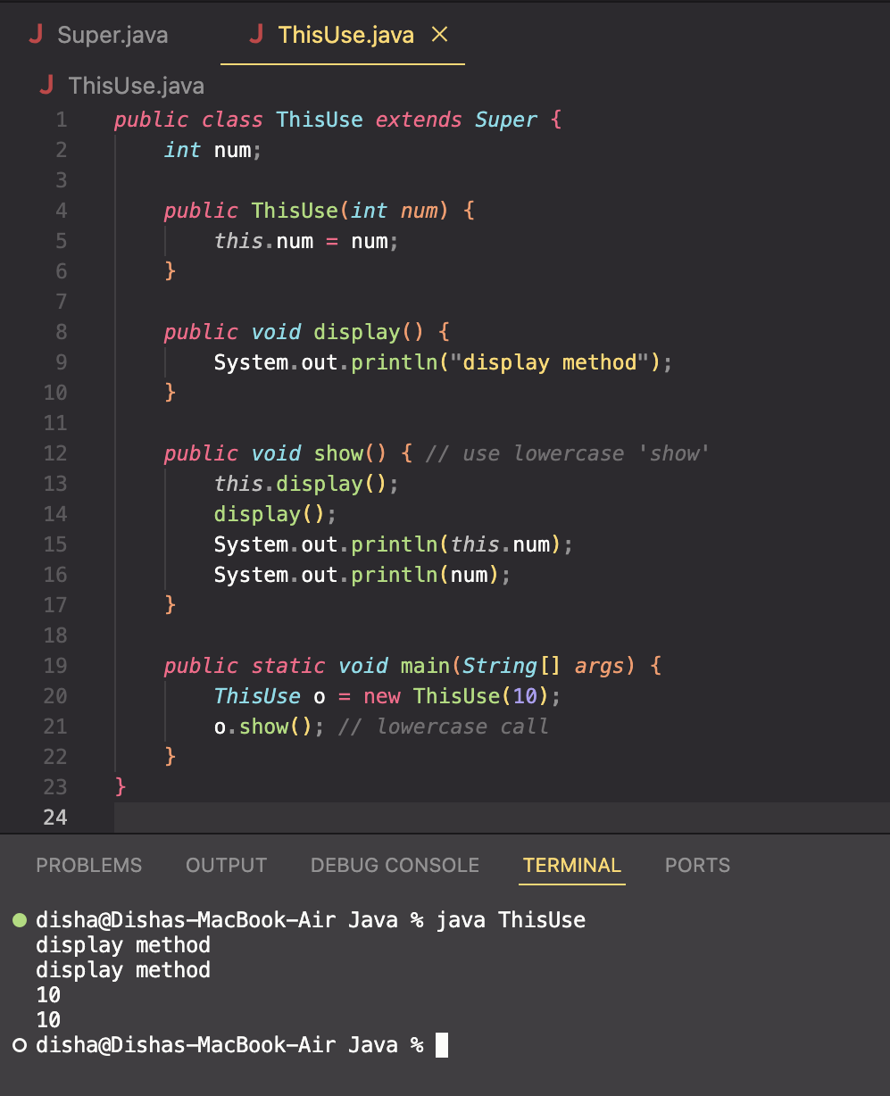

4) What is the singleton design pattern? Explain with a coding example.

Ans 4) The Singleton pattern ensures a class has only one instance and provides a global access point to it.
Example:
public class Singleton {
private static Singleton instance;

private Singleton() {
// private constructor
}

public static Singleton getInstance() {
if (instance == null) {
instance = new Singleton();
}
return instance;
}

public void showMessage() {
System.out.println("Hello from Singleton!");
}
}

5) How do we make sure a class is encapsulated? Explain with a coding example.

Ans 5) Encapsulation hides internal details of a class and provides public getters/setters.
Example:
public class Student {
private int id;
private String name;

public int getId() {
return id;
}

public void setId(int id) {
this.id = id;
}

public String getName() {
return name;
}

public void setName(String name) {
this.name = name;
}
}

6)
Perform CRUD operation using ArrayList collection in an EmployeeCRUD class for the below Employee
class Employee{
private int id;
private String name;
private String department;
}

Ans 6) import java.util.*;

class Employee {
private int id;
private String name;
private String department;

public Employee(int id, String name, String department) {
this.id = id;
this.name = name;
this.department = department;
}

public int getId() { return id; }
public String getName() { return name; }
public String getDepartment() { return department; }

public void setName(String name) { this.name = name; }
public void setDepartment(String department) { this.department = department; }

@Override
public String toString() {
return id + " " + name + " " + department;
}
}

public class EmployeeCRUD {
List<Employee> employees = new ArrayList<>();

public void addEmployee(Employee e) {
employees.add(e);
}

public void updateEmployee(int id, String name, String dept) {
for (Employee e : employees) {
if (e.getId() == id) {
e.setName(name);
e.setDepartment(dept);
}
}
}

public void deleteEmployee(int id) {
employees.removeIf(e -> e.getId() == id);
}

public void displayEmployees() {
for (Employee e : employees) {
System.out.println(e);
}
}

public static void main(String[] args) {
EmployeeCRUD crud = new EmployeeCRUD();
crud.addEmployee(new Employee(1, "Amit", "IT"));
crud.addEmployee(new Employee(2, "Disha", "HR"));

crud.displayEmployees();
crud.updateEmployee(2, "Disha R", "Finance");
crud.displayEmployees();
crud.deleteEmployee(1);
crud.displayEmployees();
}
}

7) Perform CRUD operation using JDBC in an EmployeeJDBC class for the below Employee
class Employee{
private int id;
private String name;
private String department;
}

Ans 7) import java.sql.*;

public class EmployeeJDBC {

static final String URL = "jdbc:mysql://localhost:3306/testdb";
static final String USER = "root";
static final String PASS = "password";

public void addEmployee(Employee e) throws Exception {
Connection conn = DriverManager.getConnection(URL, USER, PASS);
String query = "INSERT INTO employee VALUES (?, ?, ?)";
PreparedStatement stmt = conn.prepareStatement(query);
stmt.setInt(1, e.getId());
stmt.setString(2, e.getName());
stmt.setString(3, e.getDepartment());
stmt.executeUpdate();
conn.close();
}

public void updateEmployee(int id, String name, String dept) throws Exception {
Connection conn = DriverManager.getConnection(URL, USER, PASS);
String query = "UPDATE employee SET name=?, department=? WHERE id=?";
PreparedStatement stmt = conn.prepareStatement(query);
stmt.setString(1, name);
stmt.setString(2, dept);
stmt.setInt(3, id);
stmt.executeUpdate();
conn.close();
}

public void deleteEmployee(int id) throws Exception {
Connection conn = DriverManager.getConnection(URL, USER, PASS);
String query = "DELETE FROM employee WHERE id=?";
PreparedStatement stmt = conn.prepareStatement(query);
stmt.setInt(1, id);
stmt.executeUpdate();
conn.close();
}

public void displayEmployees() throws Exception {
Connection conn = DriverManager.getConnection(URL, USER, PASS);
Statement stmt = conn.createStatement();
ResultSet rs = stmt.executeQuery("SELECT * FROM employee");

while (rs.next()) {
System.out.println(rs.getInt(1) + " " +
rs.getString(2) + " " +
rs.getString(3));
}
conn.close();
}
}

